Q&A with author Tim Darcy Ellis
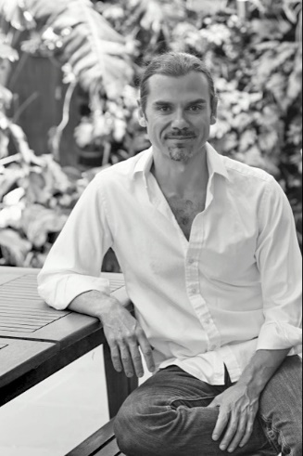
The Secret Diaries of Juan Luis Vives
Tim Darcy Ellis
PB 9780228834366 $14.99
HC 9780228834373 $24.99
272 pages/5.5 x 8.5 inches/2020
Historical Fiction
A Kirkus Reviews Best Indie Book of 2020

How did you first learn about Juan Luis Vives?
In 2008, I discovered a book – THE DISINHERITED: EXILE AND THE MAKING OF SPANISH CULTURE by Henry Kamen – when looking for a gift for a Spanish friend. Despite my lifelong personal and professional interest in English History, and Tudor England in particular, it was in this book that I stumbled upon the incredible story of Juan Luis Vives.

What interested you most of him?
Based on the Kamen book, he seemed to be the most pivotal historical figure I’d never heard of…. And I wanted to know more, but to my surprise, there were no films, no novels, and no recent biographies of this astonishing man and his life. I began researching Vives, his life, his writings, what his contemporaries and later historians said of him and imagining the story behind the story. The result is my new book, THE SECRET DIARIES OF JUAN LUIS VIVES.

Have you always been interested in Tudor England?
Yes, as a child in Surrey, England, I spent hours thumbing through history books and encyclopedias, and I was fascinated with the Tudors: Henry VIII and his six wives, the rise of the Renaissance, the power struggles between the court factions, driven by relentless ambition and religious ideology. In part, this is what led me to a career in archaeology and museums. I have maintained a lifelong fascination with the period, but I really want to hear the voices of the people that have been marginalized from the mainstream.

Why did you decide to write the book as fiction -- as a psychological thriller written in personal diary form? Did you consider writing as Biography?
I love the genre of fast-paced thrillers, and I enjoy epistolic and comic-strip work. That said, I literally started writing the book as a diary before I'd considered other forms of approaching the story of Vives. It was as if the form chose me rather than the other way around. I wanted the reader to hear the voice of the man, as I envisioned it, based on my research, with all his human traits.

Why do you think Juan Luis Vives is generally lost to history? Why do you think readers need to know about him and what do you hope they take away from his story?
His writings were banned in Catholic lands by the Jesuits, the Theologians, the Pope and by order of the Inquisition before the end of the sixteenth century. He was considered subversive, revolutionary, and critical of the church. However, in Protestant lands he was well-known into the nineteenth century and his suggestions formed the basis for the education of noble women and for poor law reformation. I hope that the reader comes to understand the struggles and the conflicts of the man in the light of the terror of the Inquisition. Also, that there were pacifists, reformers, advocates for care of the mentally sick, and for the education of women throughout the period of religious persecution who paved the way for a better future for all of us.

How did your background in archaeology effect how you approached researching and writing the book?
I was fortunate that I am very familiar with the architecture and material culture of the period, not just for the royal classes, but of the poor as well. Having worked in London I knew the backstreets of the eastern part of the city where much of the novel is based, like the back of my hand. I even knew what type of tableware would have been in use, and what timbers would have been used in the buildings. I wanted to bring the sights, smells, and sounds of the sixteenth century to the attention of the reader, using my archaeological knowledge, so that they felt that they were authentically immersed in the period.

Did your Jewish ancestry effect how you approached the story?
My Judaism definitely gave me an in-road into the lives of marginalized communities of the period, people whose stories are seldom told. My family, the Elishas do appear in the novel as part of the clandestine Jewish community of London at the time. You could say that I was biased – I don't have much sympathy for the hard-line anti-Semitic characters mentioned in the book, so I don't pull my punches when it comes to describing the horror and loss of what the Jewish people experienced at the time. I feel that the Spanish Jews survived at all is an incredible testament to the resilience of the Jewish people, and I wanted to show how Vives and others did just that.

What are you working on now?
‘The Secret Diaries of Juan Luis Vives’ is the first part of my Sephardic Trilogy. The trilogy explores the role of the key men and women whose life’s work was pivotal in enabling the official resettlement of the Jews in England – and her colonies – in the 1650s.

